**USING RAPTOR – AMSTRONG NUMBER OR NOT**

**A.V Bhargava(191911110)**

**FLOWCHART**

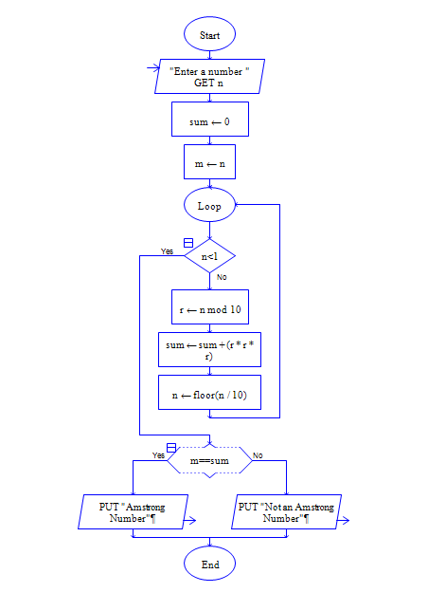

**INPUT**

371

**OUTPUT**

